**Cruise:**

Identifier

arrivalTime **time**

numOfLoader

serviceTime **minutes**

get arrival time() =>**minutes**

get num of loaders required() => **integer**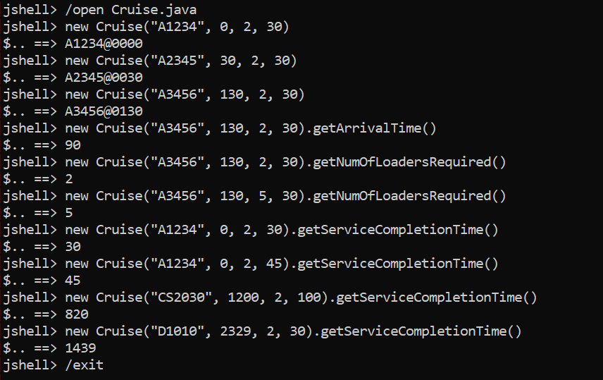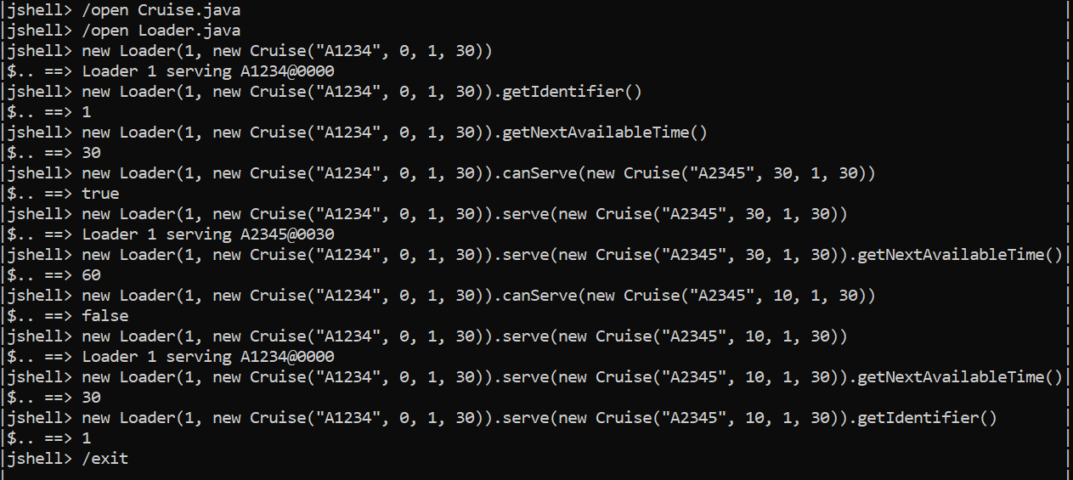

get service completion time() => **minutes**